# Fonts

Twentieth Century Monotype (Tw Cen MT)

Bell MT



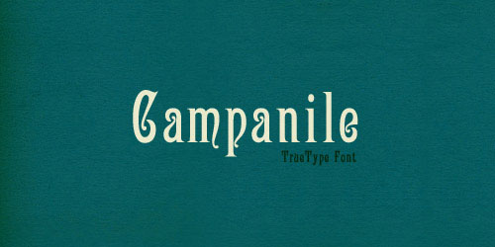

# Colors - RGB

85, 1, 14

223, 128, 18

4, 184, 219

1, 7, 95

251, 223, 62

67, 144, 16

2, 1, 15

219, 20, 0

163, 64, 32

239, 182, 69

48, 38, 37

61, 199, 137

0, 69, 77

## Color Inspiration

